Maryke Adrienne) (: Shopping List Food Technology and Hospitality (Monday - Friday)

Week 2 ending: 1May
Meat  Monday :  22 pieces of boneless chicken thighs  Tuesday:  700g + 700g beef mince  Wednesday :  12 pieces of boneless chicken thighs  Thursday:  Friday: | Dairy & Pastry  Monday :  30 Eggs  Tuesday:  2kg pizza mix cheese grated  1 + 1 large tub sour cream  Wednesday :  6 eggs  10 Ciabata buns  2 Gluten free buns  Junior:  250ml cream  2 cans of evaporated milk  1.2 kg Pizza blend grated cheese  3x loaf sandwich sliced White bread  1x gluten free bread  Thursday:  2 loaf sandwich sliced White bread  ½ gluten free bread (use what leftover form Wed)  Friday:  10 Eggs  20 Ciabata buns  2 gluten free buns
Dry Ingredients  Mixed Herbs 200g  12 cups Coarse bread crumbs  7kg plain flour  Paprika  Onion powder  Ground cumin  Dried oregano  Ground Black pepper  Tumeric  All purpose spice | Tinned Food  Monday :  Tuesday:  3 + 3 cans of chopped tomatoes  3 + 3 cans of Whatties Mexican Chili salsa beans mild  3 + 3 cans of sweet corn cernels  1 + 1 bottle of Tomato paste  Wednesday :  Thursday:  Friday:
Cleaning Products  Dishwashing liquid  Washing powder  Dishwasher tablets  Kitchen paper towel  Jik  Jif  Oven cleaner  Nappy San | Fruit and Vegetables  Monday :  20 med Kumara  10 brown onion med  4 kg pumpkin (butternut)  5 tubs cherry tomatoes  2 bunches of fresh parsley  1 large tub of garlic (used for all classes)  Tuesday:  6 carrots (3 p/class)  6 brown onions (3p/class)  Wednesday :  L1 Coleslaw  1 x Red cabbage  1/2 x large white cabbage  3 x carrots  2 x large Telegraph cucumbers  6 brown onions  Junior:  3 onions  1 red capsicum  1 green capsicum  1 yellow capsicum  Thursday:St M:  3 onions  1 red capsicum  1 green capsicum  1 yellow capsicum  Friday:  Coleslaw  2 x Red cabbage  1 x large white  6 x carrots  4 x large Telegraph cucumbers  12 brown onions
Other

3 x large bottle of sliced Gherkins sweet & tangy
2 x large bottle of olive oil
2 x Large Tub mayo
1 x bottle balsamic vinegar
2 bottles tomato chutney
2 tubs tomato relish

8 Packets of Gluten free corn Chips (4 p M-class Tuesday)

Gluten free Corn Chips
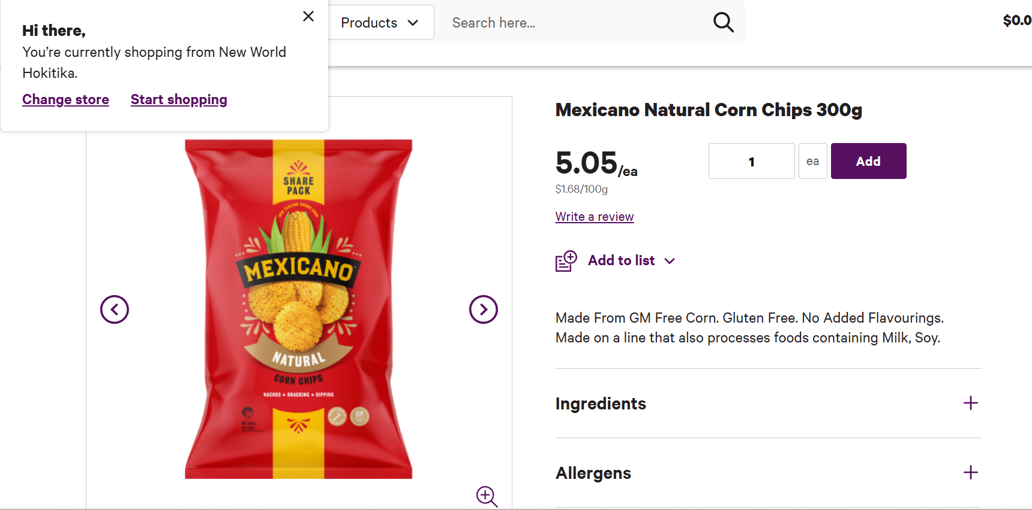

Name and date of the class | Recipe being made
Monday: L1 Hosp | Kumara Rosti stack
Tuesday: Middle school Period 1 & 2 DK, 3 & 4 RS | Nachos
Wednesday: L3 Hosp 3&4 | Chicken burger with coleslaw.pdf
Wednesday: Period 1 & 2 Juniors | Southland cheese rolls.pdf
Thursday: Period 1 & 2 St Mary’s | Southland cheese rolls.pdf
Friday: L2 Hosp Period 3 & 4 | Chicken burger with coleslaw.pdf

